Question – 1 Write a program to calculate sum of first N natural numbers.

Ans.

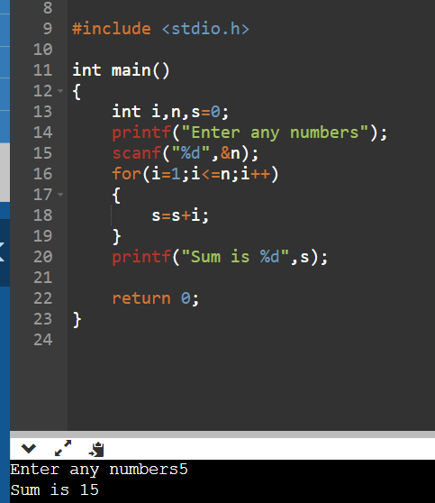

Question – 2 Write a program to calculate sum of first N even natural numbers.

Ans.

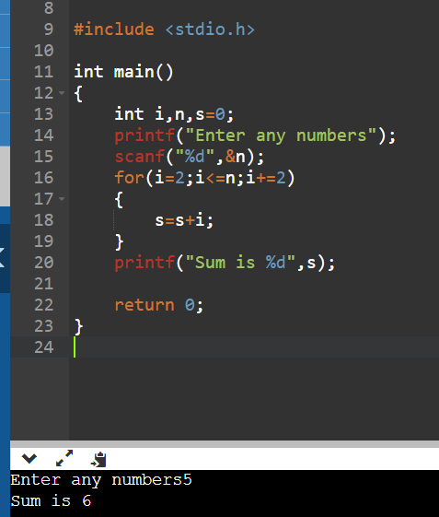

Question – 3 Write a program to calculate sum of first N odd natural numbers.

Ans.

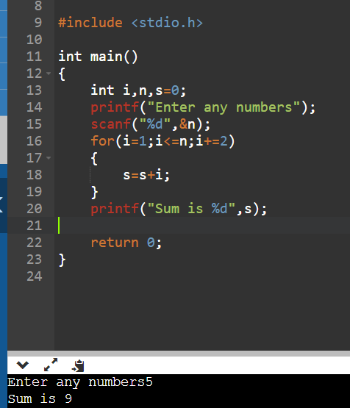

Question – 4 Write a program to calculate sum of squares of first N natural numbers.

Ans.

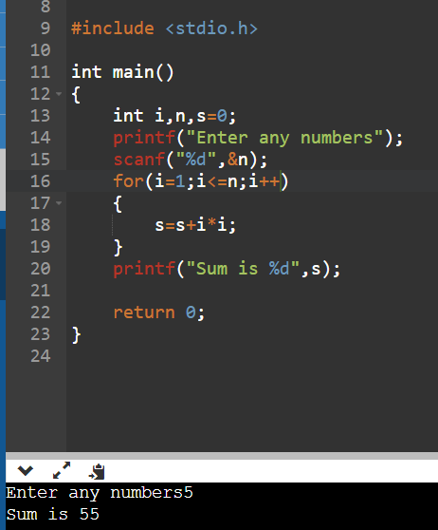

Question – 5 Write a program to calculate sum of cubes of first N natural numbers.

Ans.

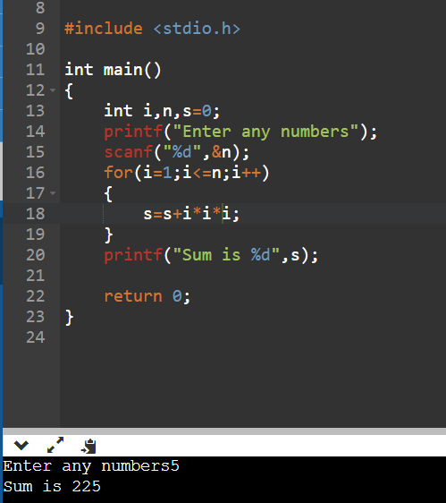

Question – 6 Write a program to calculate factorial of a number.

Ans.

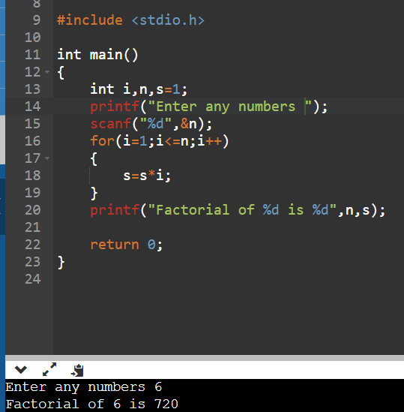

Question – 7 Write a program to count digits in a given number.

Ans.

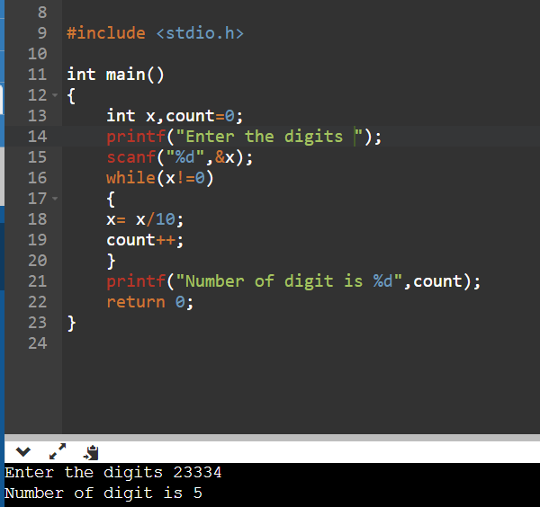

Question – 8 Write a program to check whether a given number is a Prime number or not.

Ans.

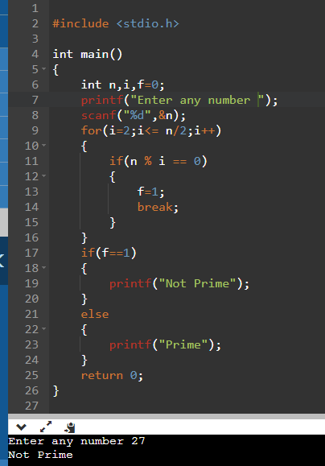

Question – 9 Write a program to calculate LCM of two numbers.

Ans.

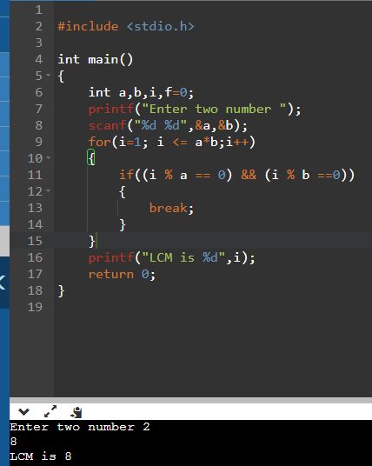

Question – 10 Write a program to reverse a given number.

Ans.

